**Property Indication**

1. **Property Information:**

|  |  |
| --- | --- |
| **Property Address:** | #D-52, St. Maha D, Phum Vimean Trung, S/k. Krang Thnug, Khan Sen Sok, Phnom Penh. |
| **Property Type** | A parcel of land accommodating an under-constructed one-storey flat (Basement completed). |
| **Front Road** | 8m |
| **Land Size** | 85sqm (as per sub- divide title deed) |
| **Building Size:** | 57.4 sqm (as per SPA) |
| **Title Deed No:** | Will have hard title |
| **SPA** | USD48,985.00 |

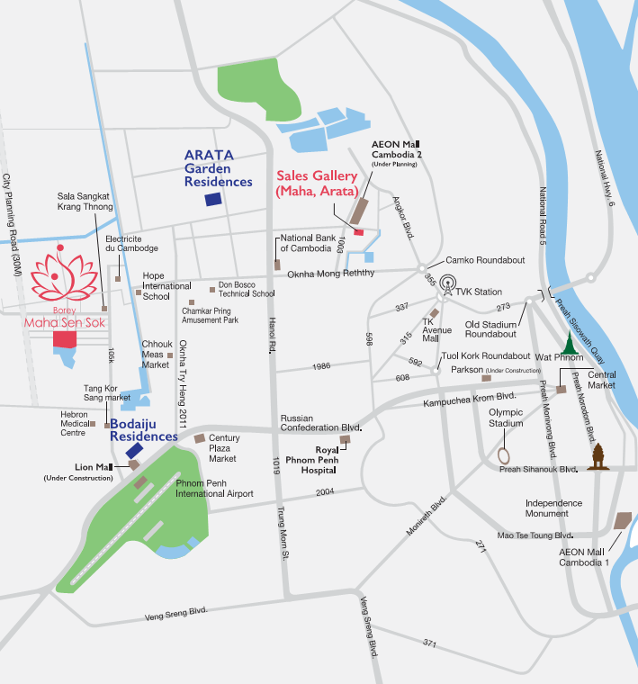

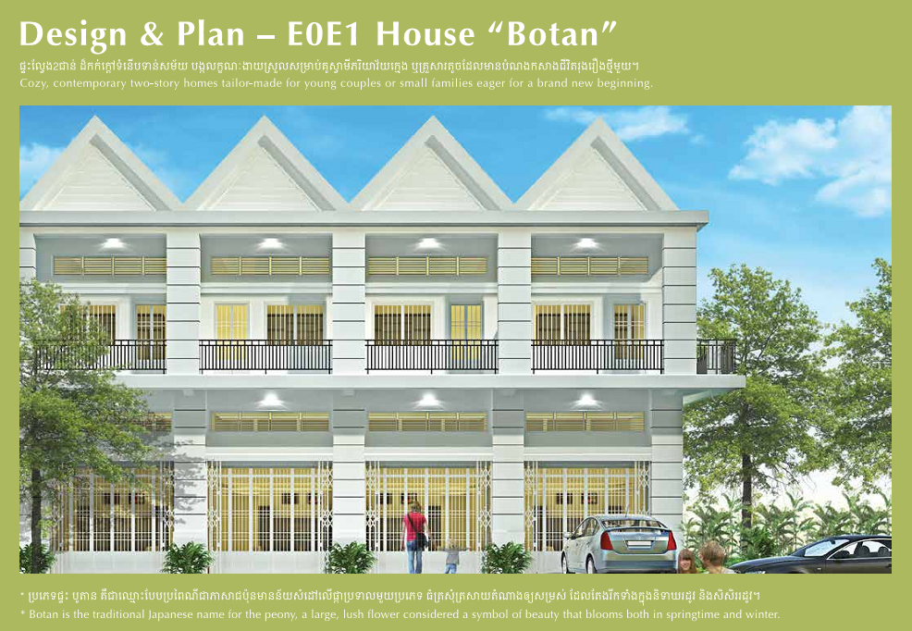

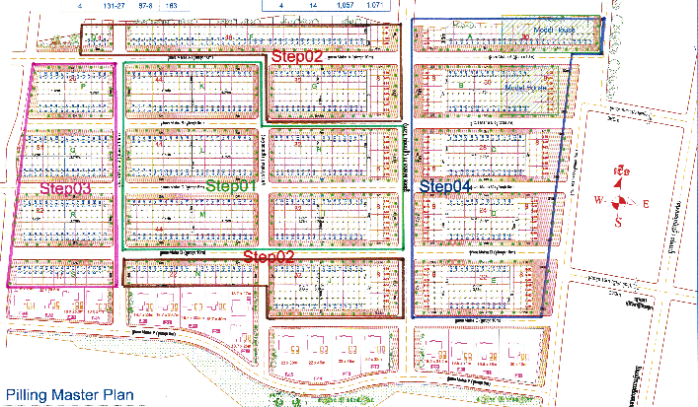

Subject Property

